
Widgets

INSTALLATION GUIDE
for Openpay Product Calculator Widget Extension for Magento 1

Step 1 :
Go to your projects root folder & then upload files and folder to the root.

If you have any custom theme then upload theme files to the current theme (app/design/frontend/<Your package>/<Your Theme>).

Step 2 :
Then login to magento admin panel: SYSTEM -> Configuration -> OPENPAY WIDGET -> Widget Setup

1. Enable the module :

Expand 'Openpay Widgets Configuration' & set 'Yes' value against 'Enable Widgets' field.

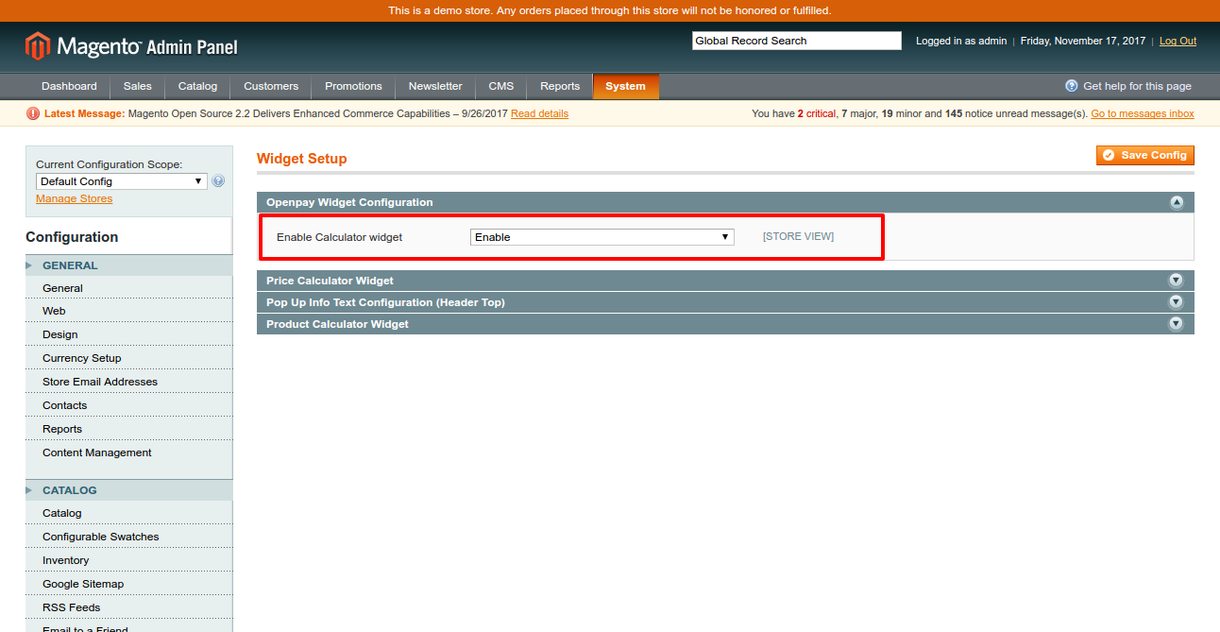

Click on 'Save Config'.

2. Set up 'Product Calculator' widget :

Expand ' Product Calculator widget' & fill out the fields as required.

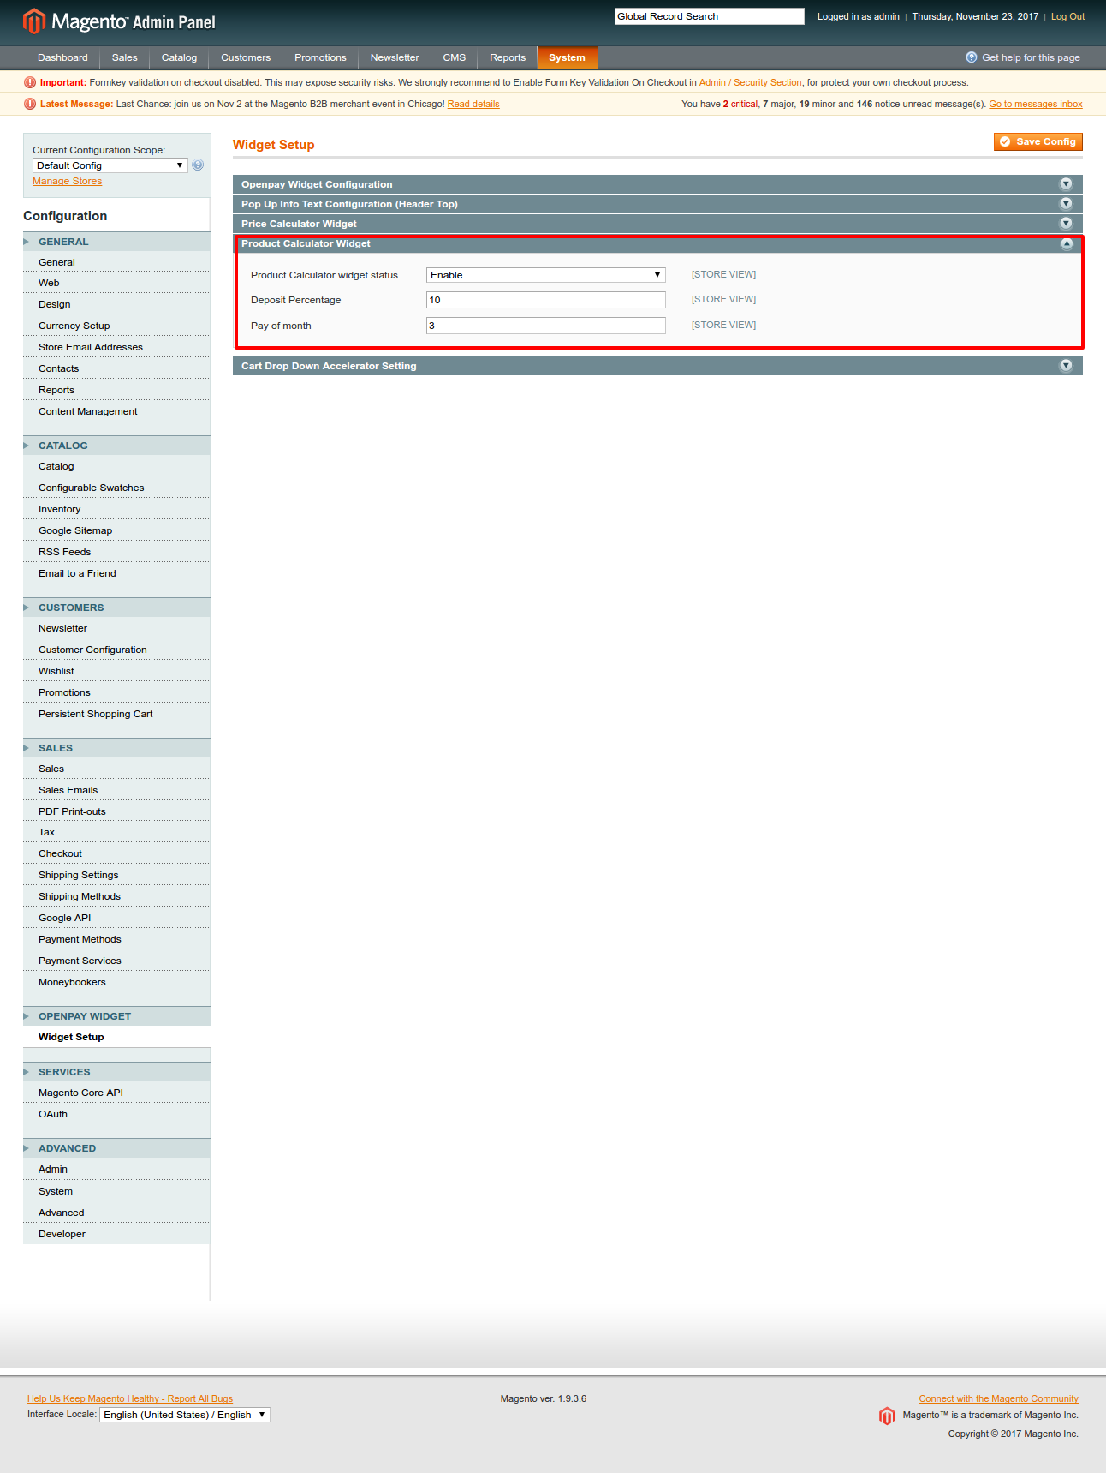

Product Calculator widget status: Enable
Deposit Percentage: Percentage amount
Pay of month: total number of months for full payment
Click on 'Save Config'.

Frontend View :

'Product Calculator' widget :

If module is enabled form admin , it will comes in product details page.

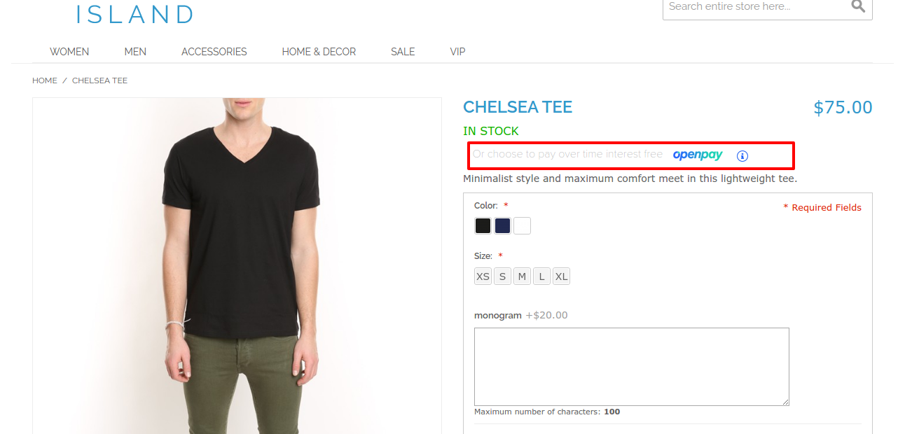

Now click on ‘i’ icon once, calculator will be display as slidedown.
Please check below image...

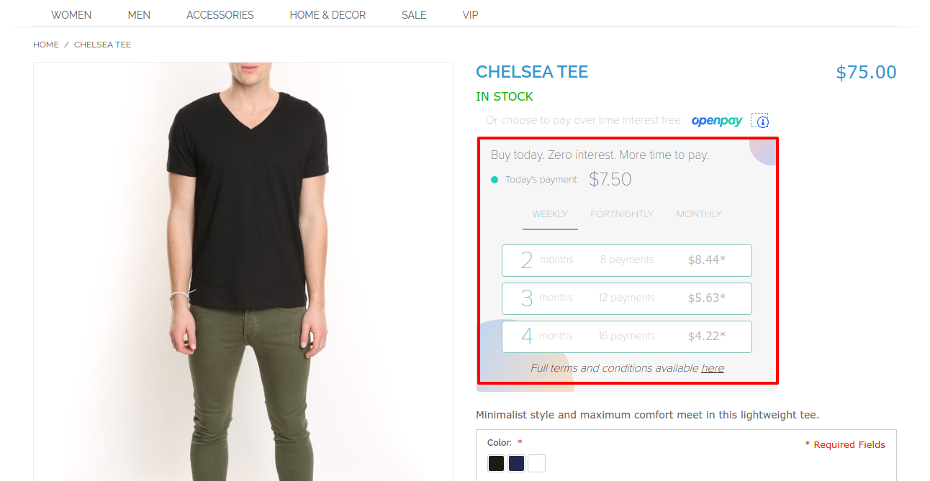
(here you can check openpay price as weekly, fortnightly, monthly order.)
Click on ‘i’ icon again , Calculator will be hide.

